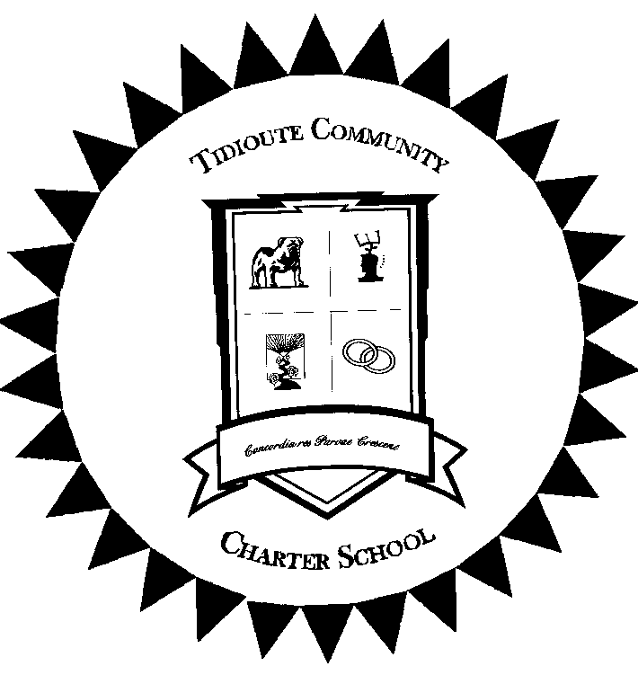
Tidioute Community Charter School
Providing a World Class Education in a Small Town Environment

End of Year Medication Pick-Up Information
Date: ___________
Student Name ____________________________ Teacher _________________ Grade ____
The end of the school year is quickly approaching! Pennsylvania regulations require all medication left at school at the end of the school year be discarded. This includes inhalers and Epi-pens. Unless your child has current permission to self-carry their medication, the school is not able to allow your child to bring the medication home themselves. If you need to make special arrangements to pick up medication, please call to make arrangements. Medications not picked up, will be disposed on _____________.
For your convenience in preparing for next year, a medication form is enclosed.
Pennsylvania Law requires that:
- New medication forms for prescription medications must be signed by the provider and parent annually. Orders are good for one year from the date they are written.
- Medication must remain in the properly labeled pharmacy or original OTC container.
- Parents or guardians must personally deliver all medication to the to the school health office (unless a self-carry order is signed by parent and physician).
- If your child’s provider has determined that your child may self-carry and self-administer their medication, please have your healthcare provider complete the appropriate portion of the medication form which requires provider consent. Parent signature is also required.
We request that you ask your pharmacist to give you a second identically labeled container for any prescription medications your student will take at school. Medication forms are available on the district web site or may be obtained from the school health office. Your physician may use their own form if desired.
Thank you in advance for your cooperation,

Susan Shiley, RN, CSN
School Nurse

